All About Martin Luther King, Jr.

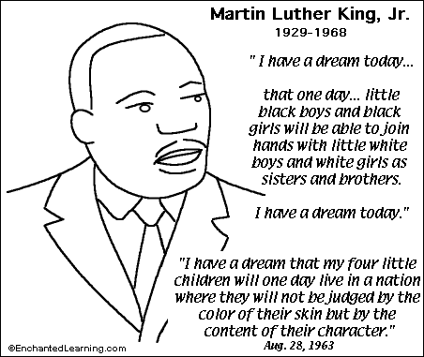

Martin Luther King, Jr., was a great man who worked for racial equality in the United States of America. He was born on January 15, 1929, in Atlanta, Georgia. Both his father and grandfather were ministers. His mother was a schoolteacher who taught him how to read before he went to school. Young Martin was an excellent student in school.
After graduating from college and getting married, Dr. King became a minister and moved to Alabama. During the 1950's, Dr. King became active in the movement for civil rights and racial equality. He participated in the Montgomery, Alabama, bus boycott and many other peaceful demonstrations that protested the unfair treatment of African-Americans. He won the Nobel Peace Prize in 1964.
Dr. King was assassinated on April 4, 1968, in Memphis, Tennessee. Commemorating the life of a tremendously important leader, we celebrate Martin Luther King Day each year in January.
http://www.enchantedlearning.com/history/us/MLK/MLK.shtml

