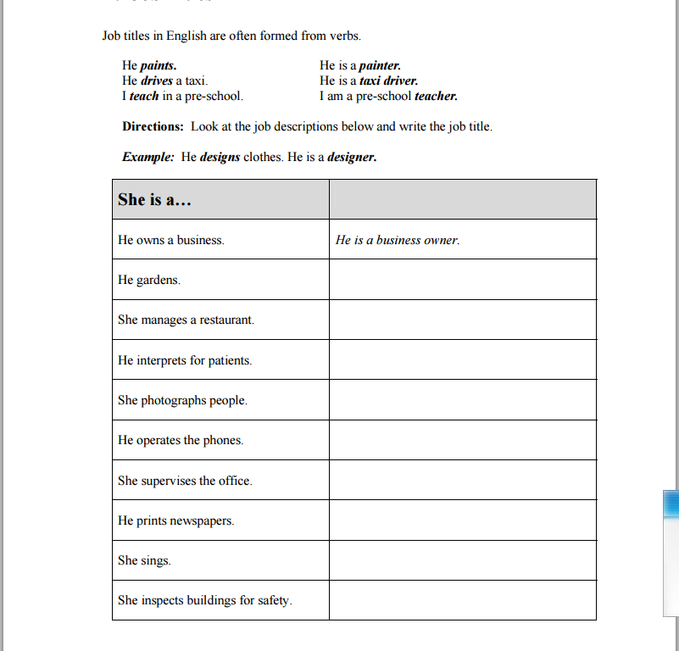

- helping people  - taking care of animals  - taking care of children  - talking with people | - working with machines  - working independently  - working with tools  - working with numbers | - fixing broken things  - planting a garden  - doing exercises  - using my imagination  - repairing cars

Cashier | Manager | Photographer
Pharmacist | Painter | Interpreter
Veterinarian | Carpenter | Sales clerk
Engineer | Postal clerk | Gardener
Chef | Driver | Psychologist
Accountant | Nurse | Tour guide
Seamstress | Decorator | Dentist

You hire and supervise workers
You check bills for mistakes and prepare tax reports
You interpret languages for people
You build houses
You guide tourists to see city sights
You sort and deliver mail
You trim bushes and trees
You sew clothing
You create new recipes
You inspect buildings
You sell things in stores
You take care of sick people
You take pictures of people
You operate a cash register
You paint houses and buildings
You care for animals
You prepare medications for prescriptions
You decorate rooms in buildings
You drive cars, trucks, or buses
You study the way people behave
You clean and repair teeth

