How Do I Get a Library Card and What Can I Do with It?

Wake County Library cards are available to all residents of Wake County.

To get your library card:

- Find your nearest library branch at www.wakegov.com/libraries/locations
- Apply in person for your library card. You will need:
- Any official photo ID (Wake Tech Student ID, North Carolina ID card, North Carolina Driver’s License, US Passport, International Passport or International ID Card)
- IF Your ID does not include your address: You will also need a piece of mail with your name and your Wake County address printed by a computer (water bill, credit card statement, power bill etc.)
- The librarian will give you your card and you will choose a PIN. Hang on to your card and remember your PIN, you’ll need it to access services!

Using the Library in Person:
- Borrow books for 2 weeks at a time to take home with you. Find books for you and the whole family! (You can renew books for 2 more weeks, but don’t return them late or else you’ll have to pay a fine!)
- Read reference books in the library
- Read magazines & newspapers in the library
- Use the computers with internet for free
- Use wifi on your personal computer or smartphone for free
- Print items inexpensively in black and white or color
- Participate in free events for adults and children in the library. Check the calendar at: www.wakegov.com/libraries/events

Using the Library’s Digital Services:
- Look up book availability before you go, and manage your loans with the Library Catalog at: https://catalog.wakegov.com/
- Find research and academic articles in the library databases at: http://guides.wakegov.com/wcpldbs

Using your Smartphone to Borrow eBooks and Audiobooks:
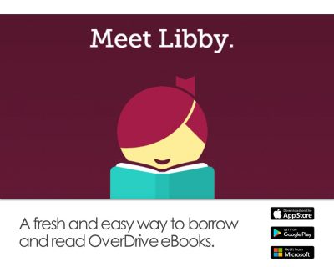
- Download the application Libby by searching for it in the App Store or Google Play Store
- Or Download the application through the weblink https://meet.libbyapp.com/
- Select your library “Wake County Public Library” or enter your zip code
- Log in using your library card number and your PIN
- Search for and borrow eBooks or Audiobooks that are currently available, or place a hold to wait for a book that will be available in the future.
- Use the app to read eBooks or listen to audiobooks!

